Daffodil International University
Department of Software Engineering (SWE)
Project/Thesis Committee
May 11, 2023

NOTICE
This is to notify that 31st Batch students for final Year Project/Thesis are asked to submit their Project/Thesis proposal by 22/05/2023. In order to submit the Project/Thesis proposal, students are asked to fill up the proposal form. Instruction mentions below,
Before go through the instruction please join google class using Code: b2izrk7
Eligibility for Thesis/Project/Internship

- Those who are going to complete 130 to 133 credits in this semester (Spring 2023), are eligible to submit the proposal for Final year Project/Thesis.

- Thesis (General): Students must have 3.00 CGPA to apply for Thesis. For less CGPA Dept. and Thesis/Project Committee will decide later by their fixed criteria.

- Project (General): Any student can take the project but you must be followed SDLC to complete the project. We highly discourage the so-called old management system project. Students must have knowledge in both Back end and front-end development for the project.

- Project (Industry): Students must have 3.00 CGPA. Students must work for renowned software companies for Industry project and must work on SDLC Steps. Industry project time is a minimum of 4 months and you must submit an appointment letter to the Thesis/Project Committee. After filling all the criteria, the Thesis/Project Committee will inform you about the result. If the result is negative then you have to take the project to complete your degree.

- Thesis (Industry): Students must have 3.00 CGPA. Students must work on renowned software companies for Industry Thesis. After filling all the criteria, the Thesis/Project Committee will inform you about the result. If the result is negative then you have to take the project to complete your degree.

- No group allowed, Individual Task .
Please follow the following instructions very carefully.

- Go to website (http://swe.application.daffodilvarsity.edu.bd/final_project/public/register)
- Complete Registration (Fill up Name, Valid email address, Password)
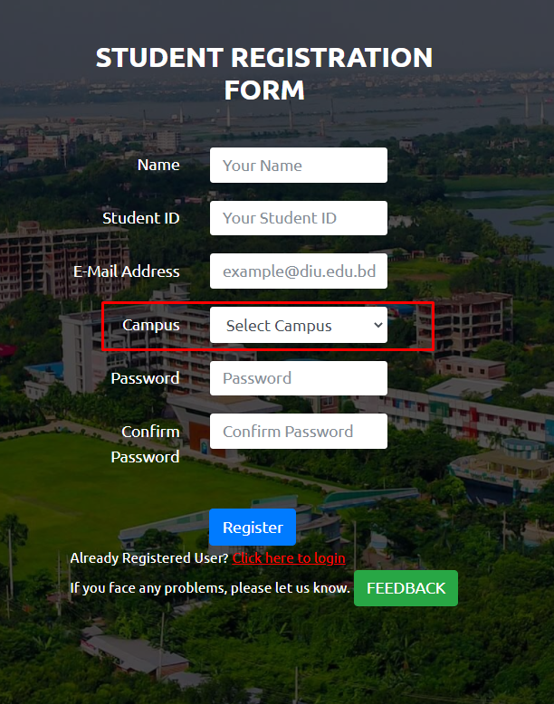

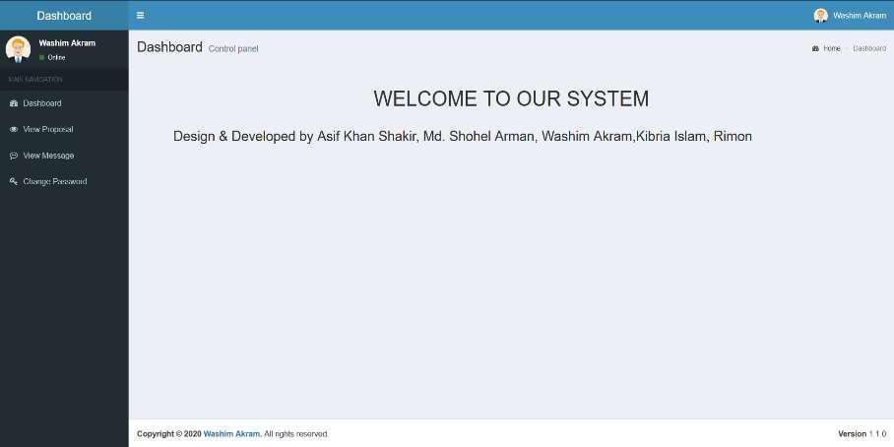
.

- If you are already registered you can be logged in using your student email id and your password.

Url: http://swe.application.daffodilvarsity.edu.bd/final_project/public/login
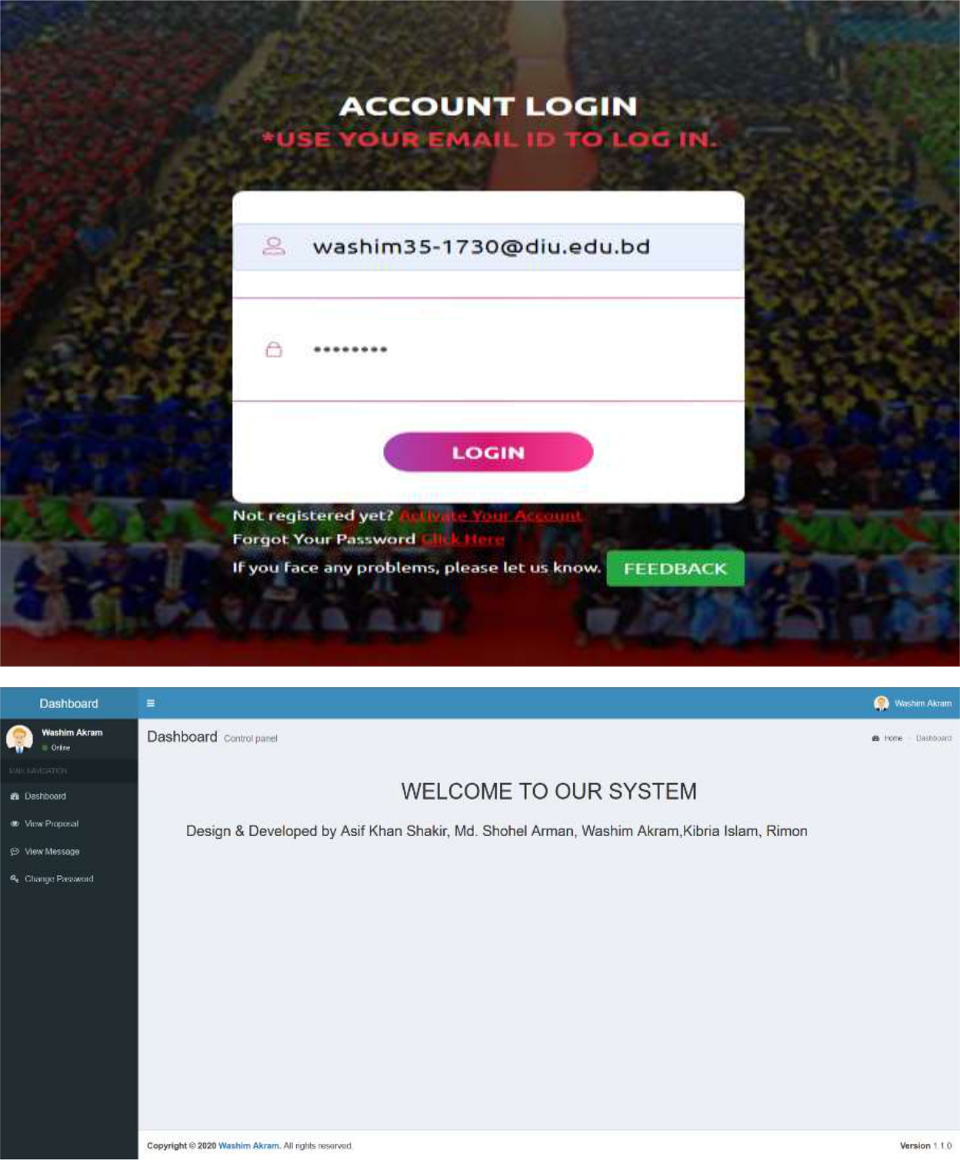

- Submit your Proposal Click Here:
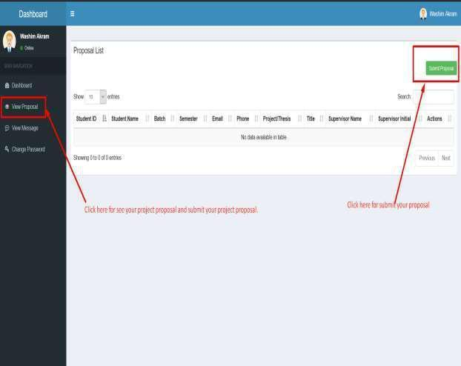

- Fill up the proposal form and click submit button. (Fill up Student ID, Batch, Semester, Phone Number, Study, CGPA, Project/Thesis/Internship, Title, Description, * If you want then you can change your name.)
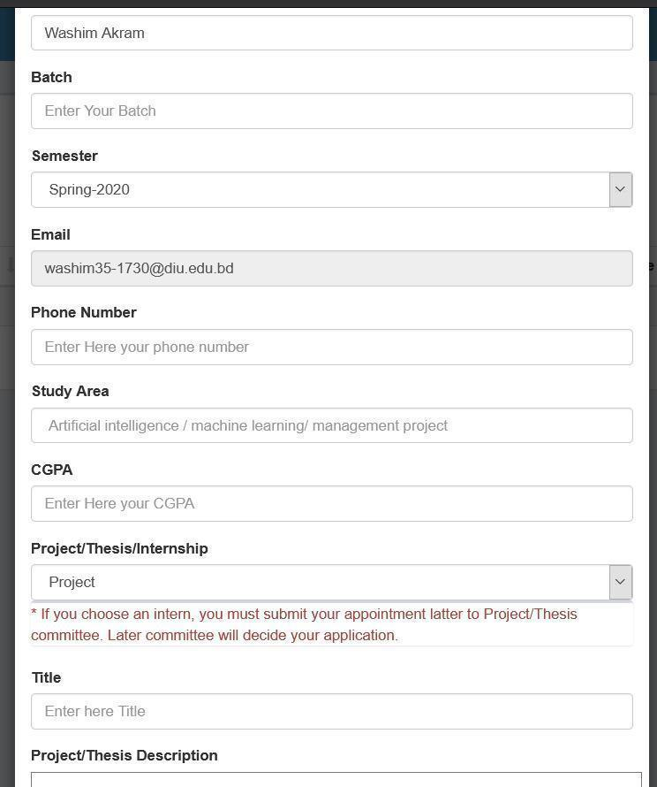

6. Click View proposal button and see your proposal accepted or pending.
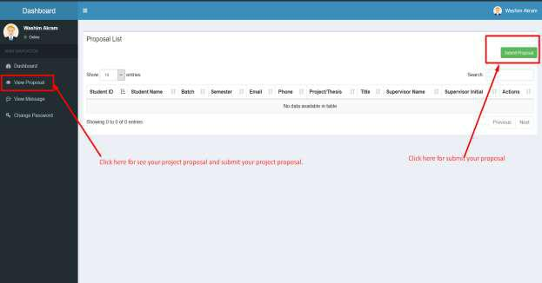
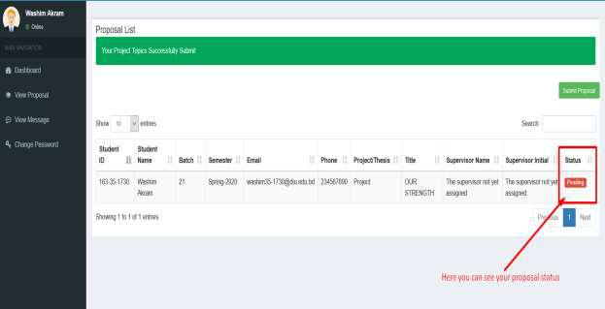
7. Click view message button and you can see your task.
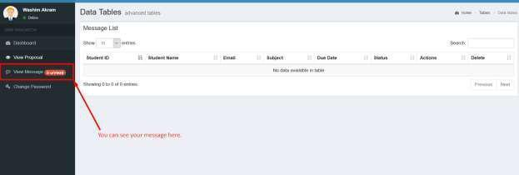

8. Click view details button then you can see details task.
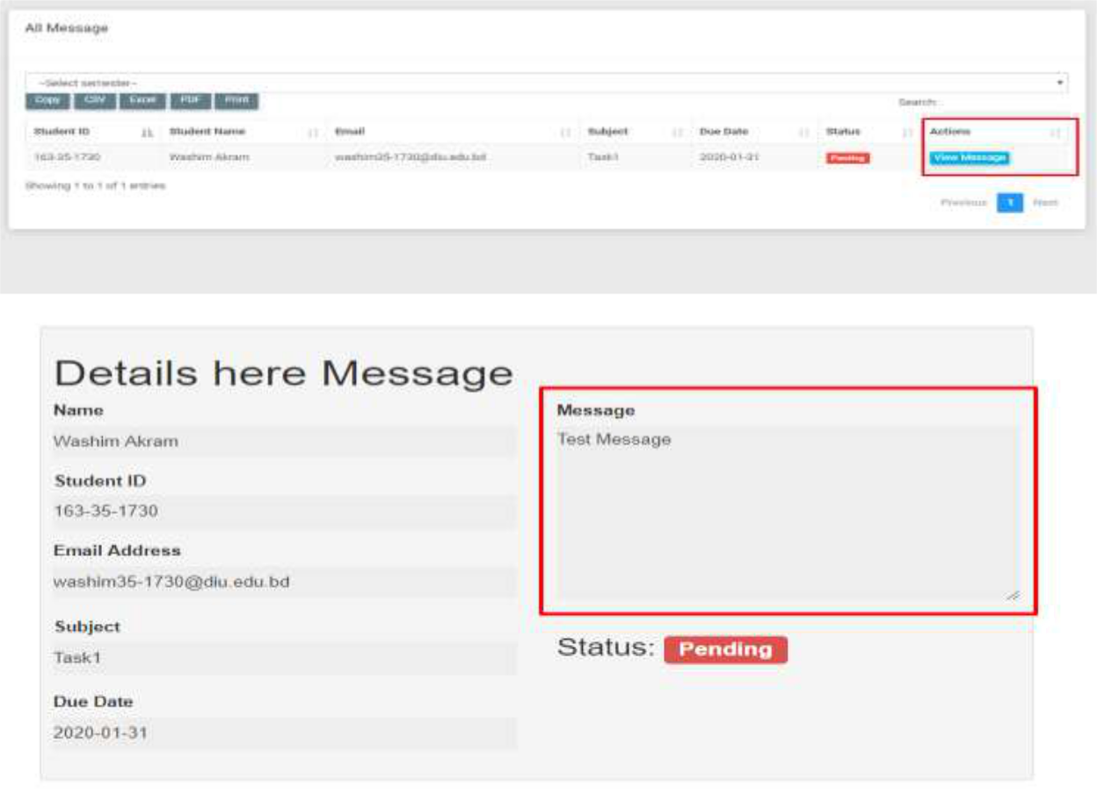
9. Here you can see notice.
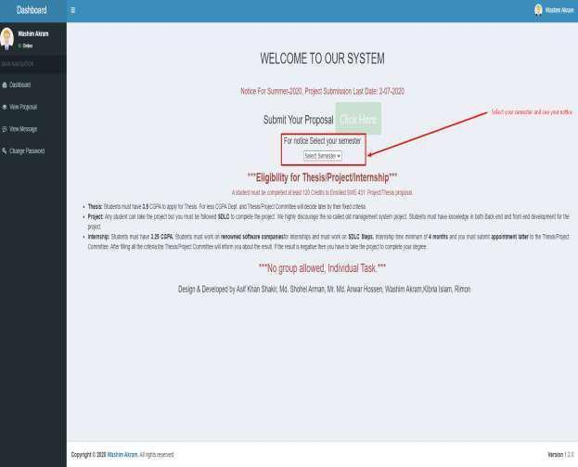

**NB: After 22 May 2023 no proposal will be accepted,

**NB: For further queries contact with this number:
01710404280, 01796679434

Khalid Been Badruzzaman Biplob
Senior Lecturer & Member, Md Rajib Mia-Lecturer & Member Secretary Project/Thesis Committee Department of Software Engineering

